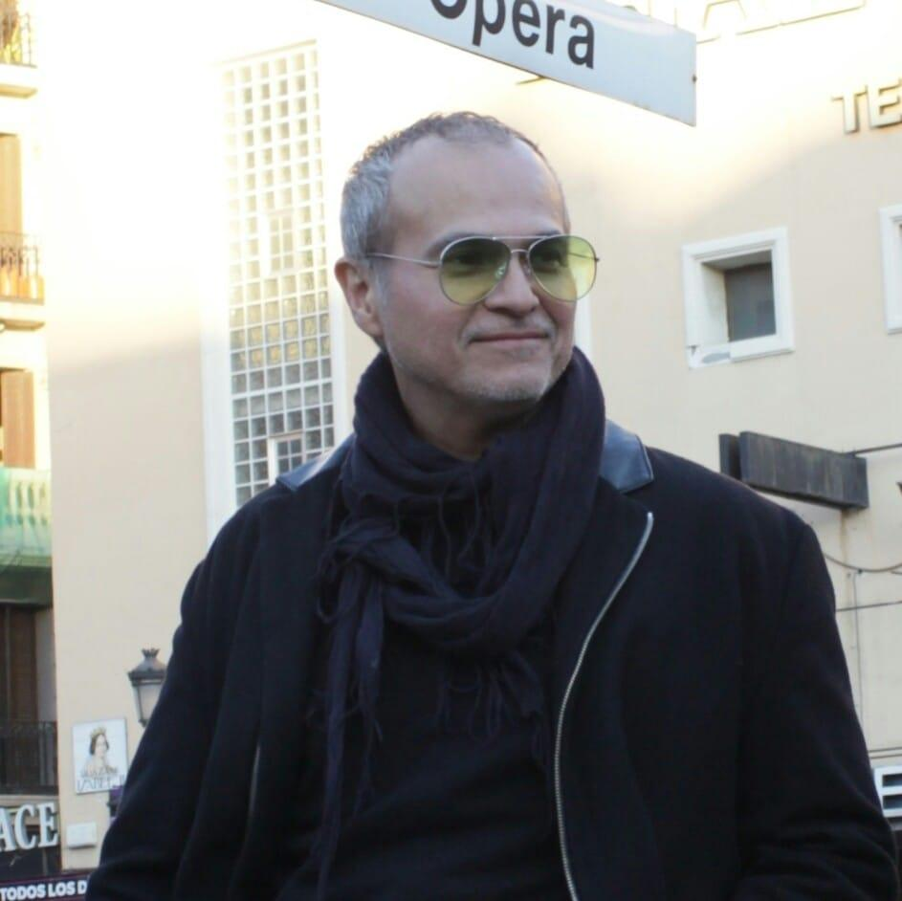
David Hinojosa Admann
Founder of the ODBK

Originally from Mexico, David Hinojosa Admann lives and works in Berlin. With a background in computer science and marketing, Hinojosa Admann studied and obtained his MFA in Madrid 2003, and has since exhibited extensively throughout Europe and Central America. He worked as an advisor for Artfacts.Net developing the "artist ranking" and online tools for art collectors. In 2017 founded the Organization for the Democratization of the Visual Arts (ODBK) an activist organization whose objective is to bring equality and diversity for the art world. Admann’s practice ranges from traditional media, like drawing and painting, to multidisciplinary and media and artistic research. His projects address the relationship between conceptual art, commerce, and democratization of the contemporary art world.

